1.Employee Salary:

from datetime import datetime

def age_calc(birthdate):
birth_year = int(birthdate.split('-')[-1])
current_year = datetime.now().year
return current_year- birth_year

def convert_salary_to_usd (salary_in_INR):
conv_factor = 0.0125
# return salary_in_INR / int(conv_factor)
return salary_in_INR * conv_factor
birthdate = input("Input Your date of birth in DD-MM-YYYY: ")
salary_in_INR = float(input("Enter Salary in INR: "))
age = age_calc(birthdate)
salary_in_usd = convert_salary_to_usd(salary_in_INR)
print("Age is: " + str(age) )
print ("Salary in USD: " + f"{salary_in_usd:.2f}")

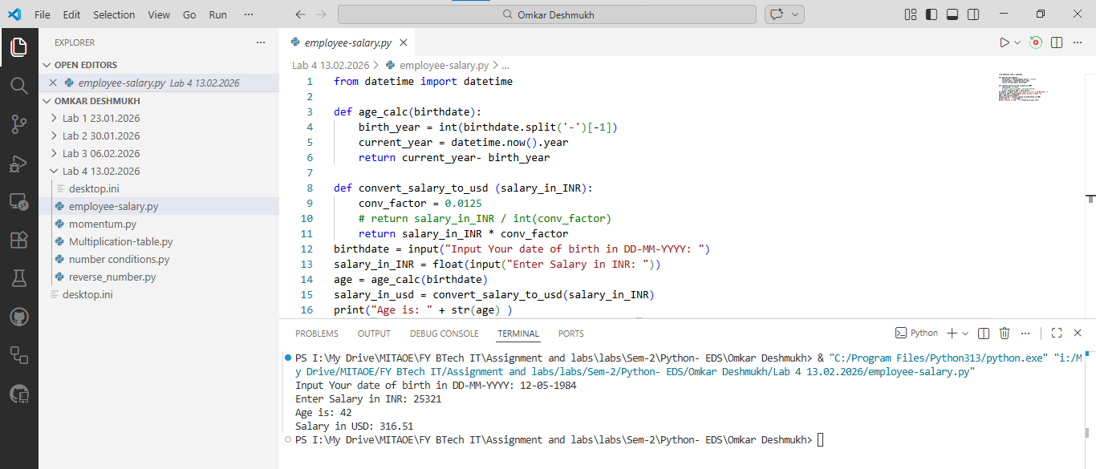

2.Momentum:
m = float(input("Enter mass in kg: "))
v = float(input("Enter velocity in m/s: "))
momentum = m * v
print("Momentum:", momentum)

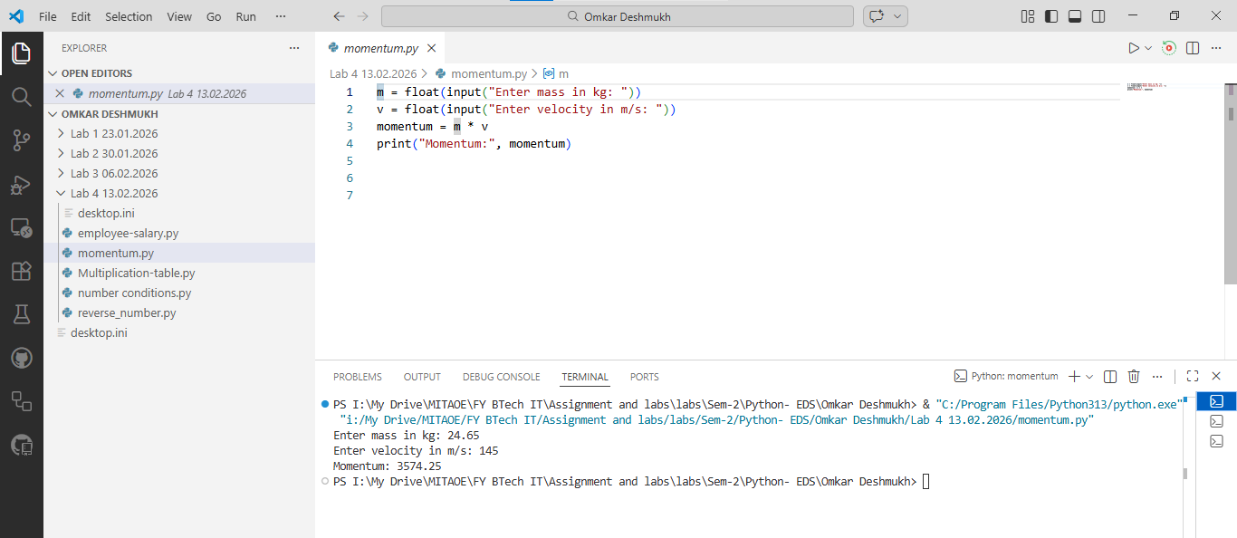

3.Multiplication Table:
num = int(input("Enter a number: "))
for i in range(1, 11):
print(f"{num} x {i} = {num * i}")

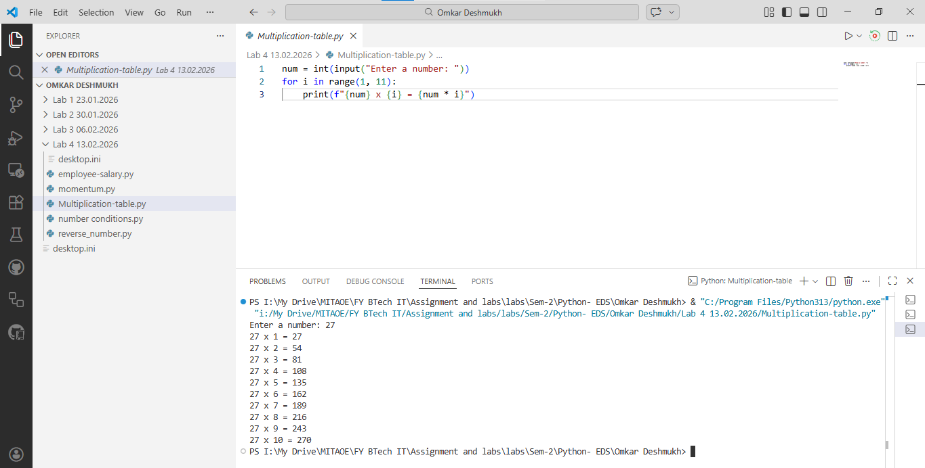

4. Number-conditions:
import math
number = int(input("Enter Your number:"))

#if number is two digits
if 0 <= number <=9:
print("square of the number is: " + number ** 2)

elif(10 <= number <= 99):
print(f"Square root of the number is: " + f"{math.sqrt(number):.2f}")

elif(100 <= number <= 999):
print(f"Cube root of the number is: " + f"{math.cbrt(number):.2f}")

else:
print("Other")

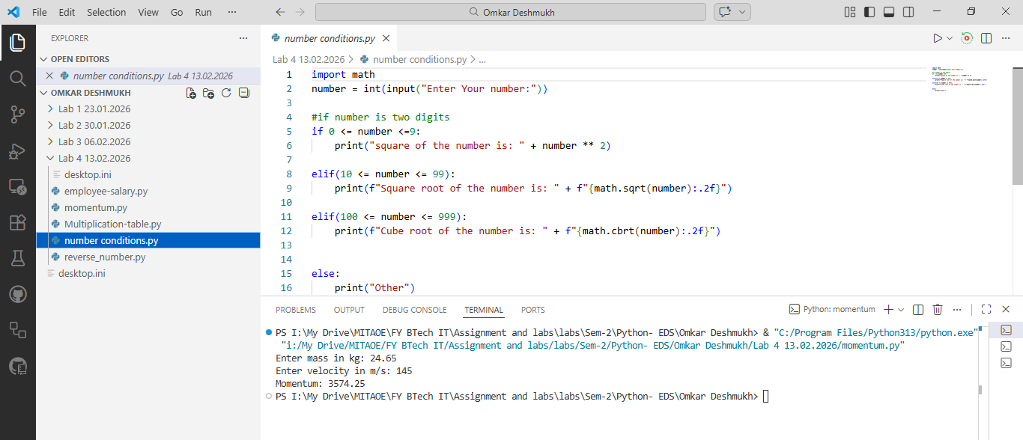

5. Reverse Number:
n = input("Enter number: ")
print("Reverse:", n[::-1])

